Motivation
In the consumer finance field, the credit default predictions have always been a core task, where each of the lending issues has to be balanced with expected return against the risk of non-payment. Misclassifying a risky customer as a safe one can directly cause credit loss, while rejecting a creditworthy customer would reduce the potential income opportunities. So, maintaining overall accuracy alone shouldn’t be considered as a sufficient objective. At the same time, default situations are relatively rare and the behaviour of customers evolves over time, resulting in imbalanced data and complex data patterns, which the supervisors are still expecting a transparent and explainable scoring system. This project’s motivation is the growing need to study how modern classification methods better align with constraints, and aims to examine how different learning objectives and strategies influence lending policy and predictive performance.

Data Cleaning Process
- Missing Values and Identifiers Check
The original raw dataset contains over 30,000 client records and 25 features. The missing value check was implied to check the dataset, which turned out to be that there is no missing value in any column. The Client ID field is strictly unique to all the observations, which is a suitable technical key, but it is excluded from modelling.

- Demographic Categorical Variables Check
For the gender variable SEX, the document only recorded male or female, so no recoding is required. There is a small number of records in the EDUCATION column, which use code zero, one, or five in addition to the main categories like graduate school, university and unknown. To avoid losing data while keeping a stable structure, all the ill-defined codes are merged into one single “others/unknown” category, leaving the four ordered levels. The MARRIAGE variable is showing a similar pattern, most of the codes are recorded as married, single or others, but still, there exists a small group coded as zero, which are later merged into the other category to keep only three valid codes.

- Age Range Checks
The AGE variable records client age in the form of years. We did a range check to confirm that there are no nonsensical values like ages below zero or above one hundred.

- Repayment Status Variables PAY one to PAY six
Most recent payments are labelled as zero, but it is then recorded as one, making it match the corresponding months in the variables’ time series. Each column is then checked again, to make sure all codes ranging from minus two to nine would fall into this set. The negative codes meaning no full repayment, are treated as valid states rather than errors.

- Bill Statements and Previous Payment
The Bill amount variables are used to understand their scale and sign, and negative number means banks owing money to the client. All six payment amount columns are confirmed to have only non-negative values.

- Credit Limit and Target Variable
The LIMIT BAL variable records granted credit in local currency, which is strictly positive for all clients, and need to pass the basic validity check. The target default payment next month has been coded as binary indicator, confirming that labelling is consistent with the problem. The check has shown that data is imbalanced but will be addressed later in the modelling pipeline.

- Ridge Regression Model

Ridge Regression Model is a linear model that uses least squares with the L2 penalty, which would shrink coefficients toward zero, and under the circumstance of presence of correlated predictors, this method still provides stable estimates. The response is a binary default indicator in our setting, but Ridge treats it as a continuous target which also produces continuous risk score .

In our project, Ridge regression mainly plays two significant roles, including representing the idea of approximating classification by regression using the squared error loss, and offering a classical and easily understood benchmark which can be compared with surrogate classification losses. This model’s shrinkage effect also helps numerical stability and avoiding extreme coefficient estimates.

- Logistic Regression Model
Logistic regression model is a linear model, linking linear predictor to the probability of default through the logistic function. The coefficients are interpreted with log odds, so the direction and relative strength each effect can be well understood by non technical stakeholders. The model outputs estimated probabilities of default for individual clients, which are directly compatible with ROC and AUC based evaluation.

In our project, the logistic regression are utilised as glassbox benchmark which is close to business practice in credit scoring. This allows us to combine both engineered behavioural features with a transparent linear structure and a loss function which is designed for classification, not for regression. In the later steps, the probabilistic output is generated including SMOTE, which is based on resampling of minority default class, validation AUC, which is for comparison and cost based threshold tuning. Due to the reason that predicted probabilities can be turned into three decision regions for credit card reviewing, including automatic approval, manual review and automatic rejection, logistic regression can provide a clear link between statistical modelling and three tier decision framework which is carefully designed for the lenders.

- Linear Support Vector Machine
The Linear SVM model is a margin which is a margin based classification that looking for a decision boundary with a large margin between the two classes. It uses an L2 penalty and a hinge loss in soft margin version which focuses on points near or across the boundary. For the numerical stability, we used squared hinge loss, which keeping the same margin based idea. Because the raw output is a distance to the decision boundary, then probability calibration was utilized to turn it into a risk score.

In our project, the linear SVM model provides an alternative linear model which uses a different surrogate loss from logistic regression. Input features and linear form are shared by both models that allows us to isolate the effects of the loss function on the learned decision rule. This assists us to figure out how a margin focused objective changes validation AUC and patterns of defaults once threshold is turned. After calibrating the SVM scores, it can be evaluated with AUC and used in the same cost based threshold search as the other two models, making comparison between L2 loss and all the other different surrogate losses quite transparent and clear in the credit default prediction.

- LightGBM Regressor (L2)
This model applied boosted trees to model the non-linear interactions and transactions in bill and pay histories. It also able to model the utilisation without heavy feature engineering. In this project the strong discrimination is needed on imbalanced credit defaults and based on business costm thresholds are then picked. The special L2 regressor can yield bounded scores that rank-risk well for the ROC/AUC and downstream cost-based cutoffs. There are some advantages of using the model on this project, which are ability to do faster training data on large tabular data, ability to solve complex and mixed continuous and categorical features.

- LightGBM Classifier
It is also a gradient boosted tree model trained with the standard binary cross entropy objective, whose output default probabilities rather than hard class labels, which fits well with our ROC curves, AUC comparison and other threshold based on the business costs. As a tree based model, capturing nonlinear effects and interactions in repayment history becomes its special advantage, where linear model is hard to represent. LightGBM has been proved to work well on the imbalanced credit data, and it also allows class weighting when necessary. To make the code better interpreted we combine the model with SHAP TreeExplainer, which provides both global summaries of importance of features and local explanations for individual clients, to make the gains of a black box leaner remain compatible with risk management, and model governance requirements.

AUC Interpretation
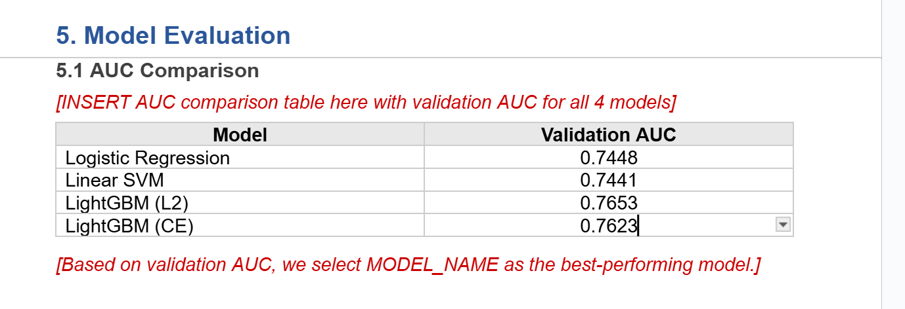
The validation result has been shown in the table above (or in appendix xxx), all of the models have achieved AUC values between 0.74 and 0.77, illustrating that defaulters are well separated from the non-defaulters, which is more effective than random guessing. Logistic regression model is performing almost identically comparing with linear SVM, with AUC around 0.744, showing that changing the surrogate loss from binominal deviance to squared hinge only affect really few in this feature set.

The Light GBM L2 and CE delivered higher validation AUC than the other models, in which L2 reaches the highest, indicating that tree based model is performing better at nonlinear capturing and interacting credit and repayment variables. So given these outcomes, Light GBM (L2) should be selected as the primary model for further analysis.

Threshold Optimization
Based on the optimal linear model (logistic regression with AUC around 0.745), F1 score is then first maximised by adjusting the classification threshold. The optimal F1 threshold is around 0.55, and the model’s overall accuracy is around 0.75. Under this threshold, the precision for default people was 0.5, and the recall was 0.59. In the confusion matrix, there are 621 correctly labelled defaulting customers, 423 customers who are misclassified (false negatives), and 624 non-defaulting customers who are incorrectly rejected (false positives). Based on the assumption that the cost of a single false negative is ten times that of a false positive, this threshold would incur a total cost of 4854, mainly driven by the high number of missed defaulting customers. We also re-optimised the threshold based on our business cost function, then the cost-minimising threshold was significantly reduced to around 0.22. At this threshold, the model identifies that most of the customers are at high risk, and the recall rate for defaulting customers improves to 0.98; the number of false negatives decreased from 423 to 20, while false positives rose from 624 to 2741. Although the overall accuracy was reduced to 0.32, the total cost also reduced to 2941, illustrating that there is around 40% cost reduction compared to the F1 optimised rule. The curve of cost-threshold curve validates this trade-off that total cost is minimised in the low threshold region around 0.2, then rises continuously when shifting the threshold to the right, which causes more defaulting customers to be misclassified as safe. It illustrates a mismatch between threshold selection optimised for symmetric metrics and asymmetric loss structure in the credit default field, where the cost of rejecting good customers is much lower than missing defaulting customers.

